**Chebyshev 5th Order LPF (Series Input)**

(Using Kuroda Identities)

Submitted By: Gaurav Gupta [1710992147]

**Schematic:**

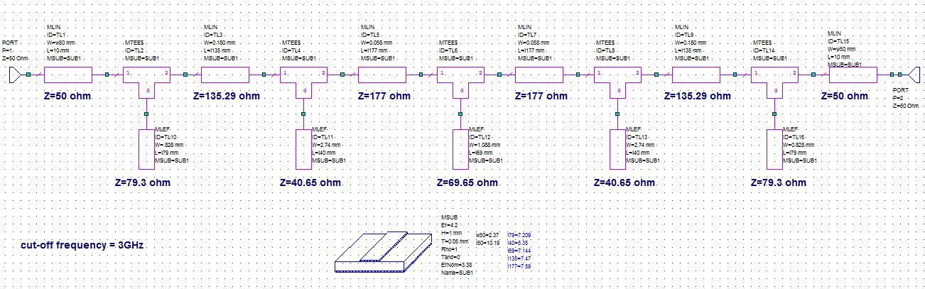

**Layout:**

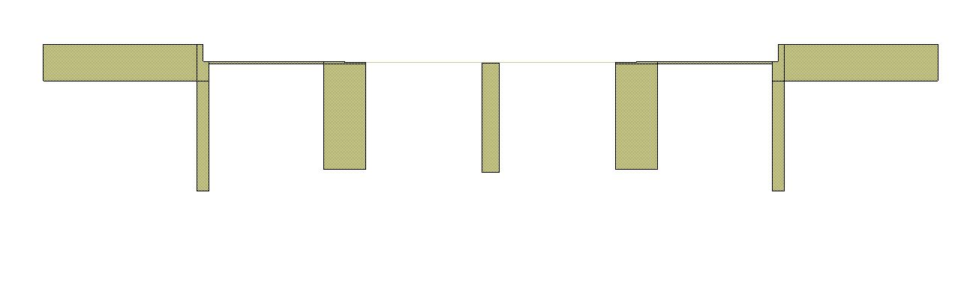

**Graphs:**

* s11 (Reflection Coefficient)

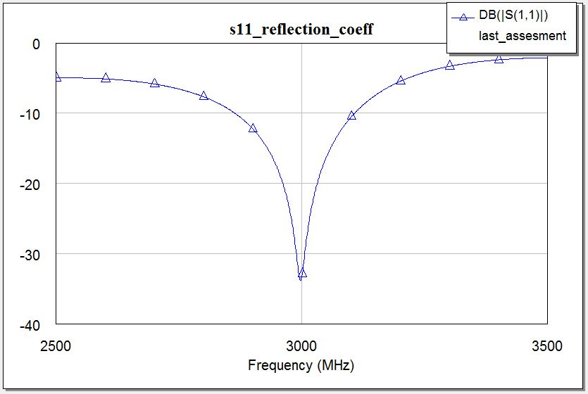

* s21 Amplification

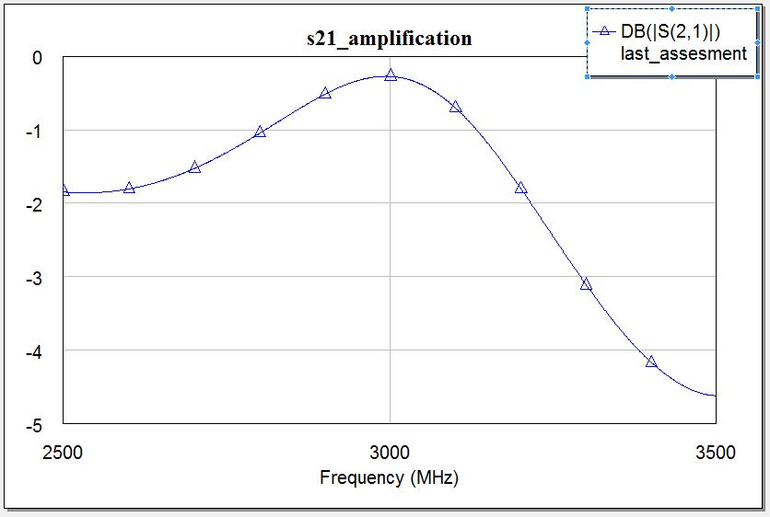

---------------------------------------------------END OF DOCUMENT--------------------------------------------